**Demonstration for Model API using Docker**

**Step 1:** cloning git repository



**Step 2:** Downloading hugging face model in local for reuse purpose.



**Step 3:** uvicorn app:app reload.

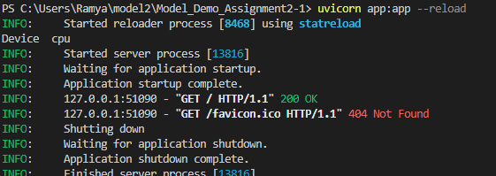

**Step 4:** test webapp using URL [**http://127.0.0.1:8000/**](http://127.0.0.1:8000/)

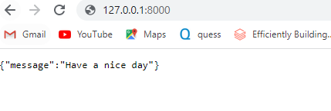

**Step 5:** install requirements.txt

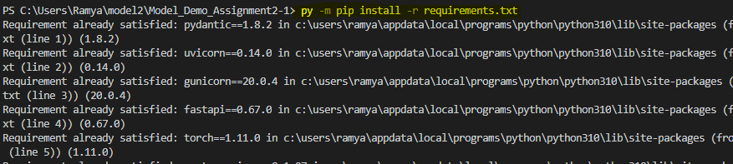

**Step 6:** building docker image

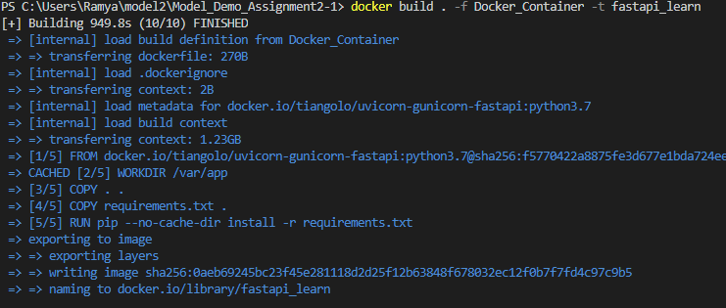

**Step 7:** run docker image

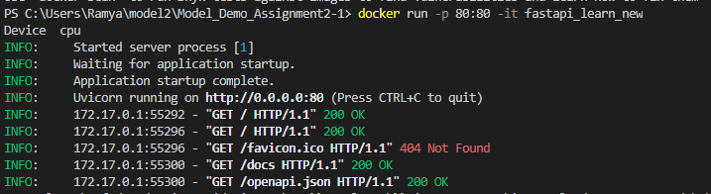

**Step 8:** testing docker in local host URL **<http://127.0.0.1:80/>**

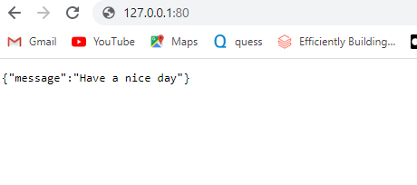

**Step 9:** testing docker in Fast API : [**http://127.0.0.1:80/docs**](http://127.0.0.1:80/docs)

**GET**

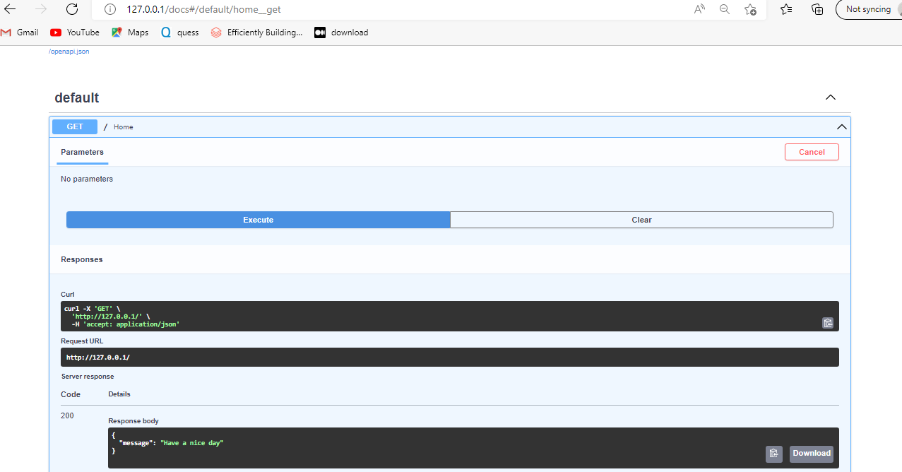

**POST Function Payload**

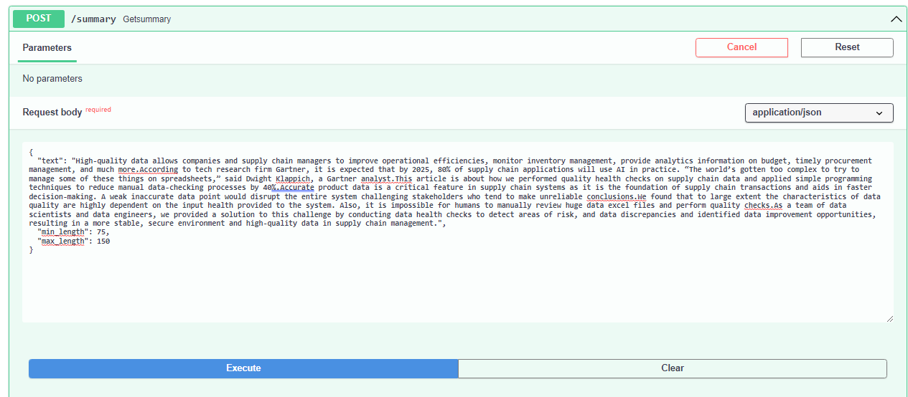

**POST Function Response : The model responded back with a summary**

